COMP 3009 Project Report

Particle Systems

Table of Contents
Course: COMP 3009
Date: 9/ 4/ 2024
Student Name: Ho Nam Leung
Student Number: 101197127

1. Introduction 3
2. Project 4
2.1 Project Overview 4
2.2 What special features were incorporated into the Project 7
2.2.1 Special Elements 7
2.3 Originality 9
2.4 External Resources 9
2.5 What was not accomplished 9
2.6 What was hard 9
3. Project Work 9
4. Grade 10
5. Conclusions 10

List of Tables
Table 1: Project Schedule - this table presents the estimated work time vs. the actual time that it took to complete the tasks. 9

Introduction

Our project is to implement some particle systems and create an Api for it so that it can be included and used in other programs, like a library.
Our motivation for the project is that we want to learn more about how computers render particle effects on screen after seeing particles from games. We noticed that a game called Counter Strike 2 has a smoke grenade, which when used, creates a cloud of smoke which not only blocks the vision of the player, but can also interacts with other world objects like bullets. We would like to learn more about particles and how they function inside a program.

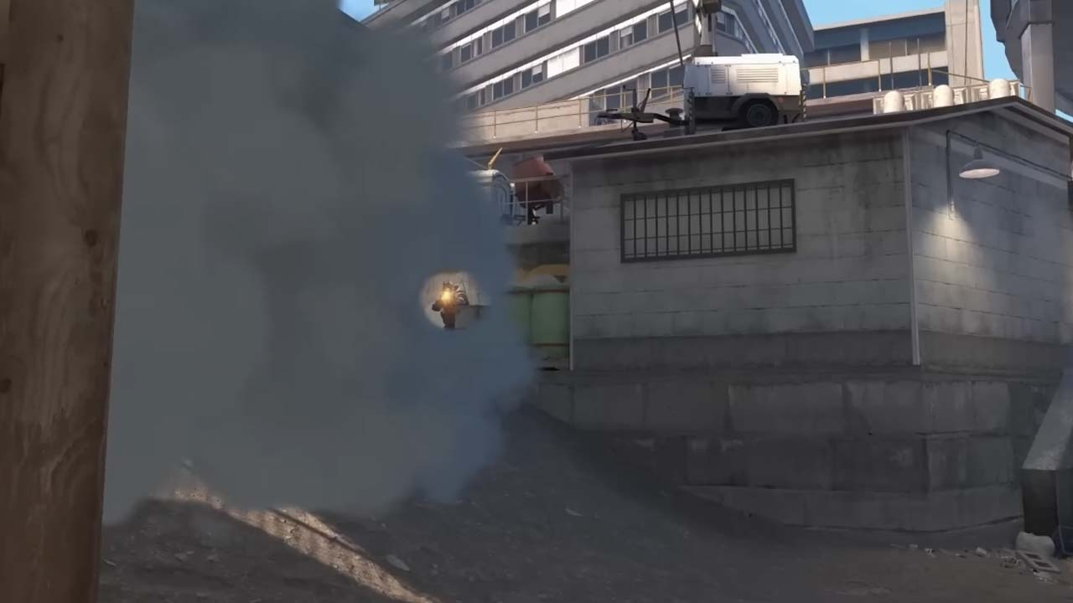
Figure.1 Abullet passing through a cloud of smoke particles.

We plan to implement simple particle systems that can hopefully create particles that resembles smoke. At the start of the project, we only know that most computer graphics are handled by rendering triangles. We are fascinated by the fact that complex graphics such as smoke particles are rendered in the same way. We would love to learn more about the logic and implementation behind the particle systems, and to try and create decent looking particles ourselves. We ended up successfully creating a simple particle system that can be modified or extended to create different particle effect. In the following paragraphs we will discuss about the details of the project, how we manage to implement the particle effects, and what we have accomplished.

Project

Project Overview
Our goal is to create a working particle system that can be customized to show different effects, and lastly to package it up so that it can be used by other programs. Due to the limited understanding of how computer graphics work, we didn’t hold high expectations, and only expected to create very crude looking particles, but end up getting a decent result.

First, I would like to talk about the design and structure of the code.

As we aim to make it so that it can be used by other systems and can be modified to create various effects of the particles, I decided to use object-oriented programming to abstract away repeated codes and details. I created a parent class EmitParticles that handles the reading and transferring of the data to the shader program. Inside the parent class, there are various functions that can be used to change the details of the particle system, such as particle color and physics variables. The parent class uses GL_POINTS to render particles, and is only capable of rendering simple particles.

Here is a list of functions that can be used to customize the particle system, we will discuss on what each variable does in detail later.

- renderInPoints()
  - sets the system to be rendered by GL_POINTS
  - can be used to create particle systems with simple point particles.
- renderInTriangles()
  - sets the system to be rendered by GL_TRIANGLES
  - can be used to render complex particles which includes plane and cube particles.
- renderWithColor()
  - sets the system to be rendered by vertex colors.
- renderWithTexture()
  - sets the system to be rendered by texture files.
  - not implemented
- setNumParticles(int num)
  - sets the number of particles to be rendered
    - does not represent the total number of vertices.
    - each particle might have one or more vertices.
- setParticleColor(Vector4f Color)
  - sets the color of the particles
- setParticleScale(float x, float y, float z)
  - sets the scale for particles rendering with triangles
- setParticleScale(float point_scale)
  - sets the scale for particles rendering with GL_POINTS
- setRollingAngle(float min, float max)
  - sets the range of roll for the randomly generated particle direction vector
- setYawAngle(float min, float max)
  - sets the range of yaw for the randomly generated particle direction vector
- setPhysics(float gravity, float cycle, int acceleration_type, float initial_speed, float final_speed)
  - sets properties for physics handling in the shader

Please be noted that renderInPoints(), renderInTriangles(), setParticleScale() and setPhysics() works after the particle system has been set up (the setUp() function has been ran). Other functions only work before the set up is done.

These functions allows users to customize the particle systems to achieve their desired effects. Users are also able to create custom geometries by overriding the createArray() function after setting up a child class, and set the vertex positions, colors and index as they desire.

In the program, a number of child classes has been implemented to render particles differently. Here is a list of child classes and what they do.

- PointEmitParticles
  - render particles with GL_POINTS
- PlaneEmitParticles
  - render 2d (square) particles
- CubeEmitParticles
  - render 3d (cube) particles
- FlameEmitParticles
  - extends CubeEmitParticles
  - renders a fire
- SmokeEmitParticles
  - extends PlaneEmitParticles
  - renders smoke

After talking about the class structures and designs of the code, lets move on to the implementation.

The particle system sets itself up by fetching for vertex information using the createArrays() function, then it generates a list of vertices and indices based on the number of particles set by the user. It then randomly generates a normalized directional vector and a phrase value for every particle, puts it in a structure and passes it to the shader.

After the setup is done, the main solution will update the particle system by providing a delta_time variable, which is used to keep track of the object’s spawned time. During the rendering process GL_BLEND is enabled, and depth mask is disabled. Then the spawned time, along with the physics variables and the transformation matrices are passed to the shader for processing.

All movement of the particles are handled by the shader. The positions of the particles are determined by these properties.

- cycle
  - time for the particles to move before its being recycled
- acttime
  - current time in respect to a cycle
- initial_speed, final_speed
  - starting speed and ending speed for the shader to find the acceleration
- gravity
  - downwards acceleration for the particles

The shader first find the acttime using the current time and cycle, then it calculates the acceleration, and uses physics equations to find the displacement of a particle. The displacement is then applied to position to find the current vertex position. Then the particle is rendered with it’s vertex color.
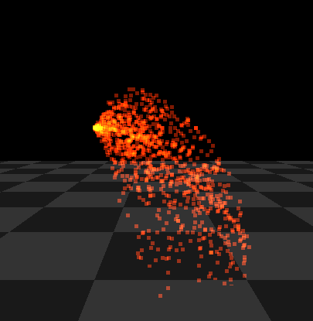

Figure.2 Gravity acting on the particles

I have also created a cube in the world to test the effects of the smoke particles. The smoke particle system worked as expected and is able to cover up the cube.
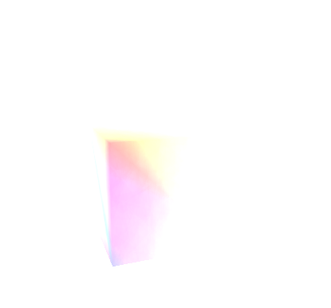
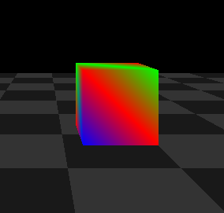
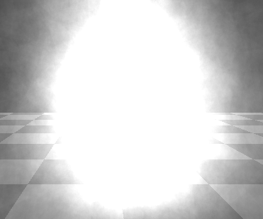
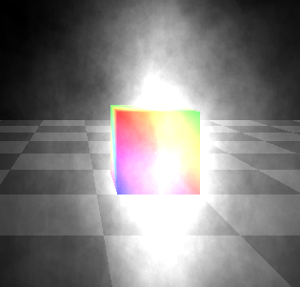
Figure. 3 no smoke Figure. 4 Figure. 5 Figure. 6

smoke partially covering cube smoke completely covering cube cube barely visible in smoke

What special features were incorporated into the Project
- GL_BLEND is used when rendering the particles.

Special Elements
As GL_BLEND is enabled for the particles, it creates an effect where the more particles there is at a place, the brighter it will be in that area, which creates a perfect effect for smoke and fire.
However, it creates a problem where if too much particles are in one place, it becomes overly bright. I attempted to solve this problem but to no avail.

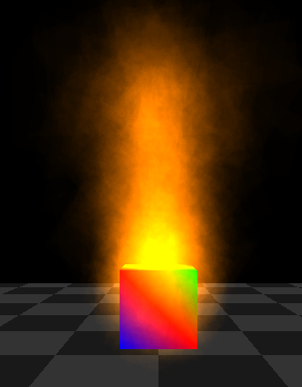
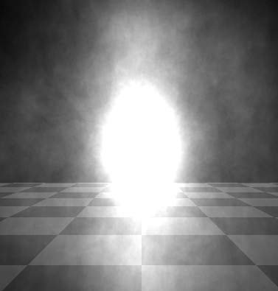
Figure. 7 The Fire is brighter near the center

Figure.8 center of smoke becomes overly bright.

As can be seen from the pictures, I am able to achieve decent results in terms of particle physics and appearance but am unable to solve the problems that were mentioned.

I have tried to make the particles move quicker at the center and slower on the side. I attempted to use a constant deceleration, and an oval-equation-based deceleration where the speed to time equation is an oval equation, it decelerates very slowly at the start and rapidly at the end of its cycle.

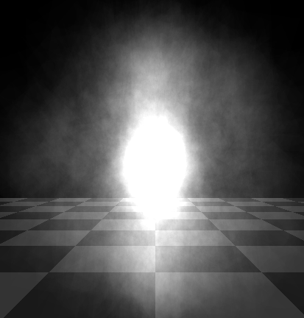
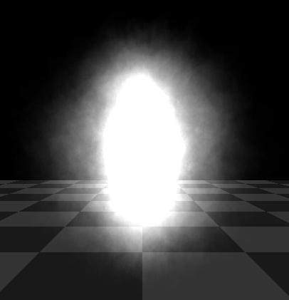
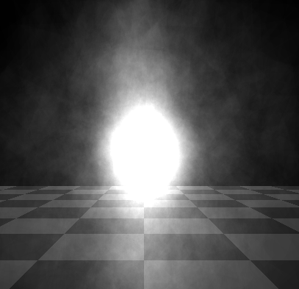

Figure. 9 constant speed Figure. 10 constant deceleration Figure 11 oval equation deceleration

As shown in the figures, changing the decelerations did not solve the problem. A lot of particles are still clumped at the center.

I figure creating an area particle system where particles are not to be emitted at a point, but to be spawned in an area randomly, and moves towards different directions. In theory it should solve the overly bright center problem as particles are more likely to not be at the center compared to the current emission-based system, but unfortunately, we did not manage to implement that system in time.

Another problem that I faced is that when rendering multiple transparent particles together using GL_BLEND, I must disable GL_DEPTH_TEST for OpenGL to properly render all the particles, but by doing so, other opaque objects will also be rendering with GL_BLEND.
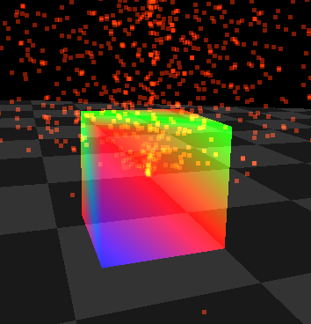
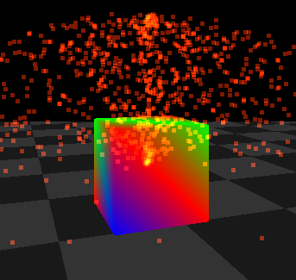
Figure. 12 cube is rendered as transparent.

Figure. 13
cube is rendered as opaque but
particles behind cube are being rendered.

I tried to enable GL_DEPTH_TEST right after the particles have finished rendering. Although the cube has successfully been rendered as opaque, the particles that are behind the cube were also rendered as they had GL_DEPTH_TEST disabled.
I tried to enable GL_DEPTH_TEST for everything, but the particles does not render properly as only the first layer of particles are rendered.

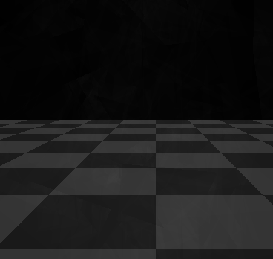 Figure. 14 barely any particles are seen

I managed to solve this problem by turning off GL_DEPTH_MASK instead of GL_DEPTH_TEST during the rendering of the particles. This allows transparent objects to render without affecting the depth buffer, hence the particles are able to render as normal with each other without the depth test, while only the particles in front of the cube is being rendered like rendering with depth test.

Originality
Everything in the project is implemented my me and is original. One unique part is that the setup function of EmitParticles class creates the vertex and color lists using a createArray() function, which allows it’s children to override it and create their own geometry, and can still use the same createVAO function in the parent without the need to rewrite it.

External Resources
No external code was used. This project is based on the lighting assignment code, and every new code since the assignment has been written by me.

What was not accomplished
We planned to implement the area based particle system, but we were unable to finish it in time.
We also planned to allow the use of texture files for each particle, but we did not implement that feature.

What was hard
The most challenging part of the project would be fetching the data from the createArray() function, writing it into a vertex structure and sending the data to the shader. The reason is I am not good at dealing at data transfers. When implementing createArray(), I often ran into memory problems. And for sending data to the shader, I have no way to know if the data has been sent and stored correctly by the shader. When the shader has an error, it often just does not render anything and show a black screen instead of telling me what the error is. That makes debugging it very difficult.

Project Work
I spent about one week constantly working on the project. I have not follow any methodology.
However, this project took way shorter than my estimated time. This might be due to my prior experience in rendering 2d particles with OpenGL.

Task | time Estimates | Actual Time | Reasons
Overall effort | 2 weeks | ~1 week | Had prior experience with 2d particles
Researching and Design of Project | 1 day | < 1hour | Project objective is simple.
Design of code | 2 days | ~2 days | Need to design classes so that it will be easy to extend.
Implementation | 1 week | 3 days | Code sometimes crashes without providing useful feedback.
Integration and testing | 1-2 days | 2 days | Feature creeping.  New problems appear after finishing parts of the code.
Incorporation of special features | N/A | N/A | already included in the implementation time.
Table 1: Project Schedule - this table presents the estimated work time vs. the actual time that it took to complete the tasks.

Special Instructions
For compiling, please include all the OpenGL Library such as freeglut and glew.
To use the code, right click to access the menu. Most features implemented are accessible through the menu.
To move the camera, use WASD for movement, arrow keys for look direction, QE for tilting,
RF for going up and down, ZX for zooming in and out.
Most of the keys on the keyboard are responsible for certain actions, but all actions are accessible through the menu.

Grade
I feel like this project deserves at least 85-90 as I have put a lot of effort into doing this project. Although there are planned features that weren’t implemented, and unlike other teams, I did not add additional features that isn’t from the scope of the project, but I believe I have fulfilled the objective of this project very well. The code works as intended and I have learnt a lot from this project.

Conclusions
This section shall provide a summary of the project. Provide insights into the project, your recommendations, and ideas for future work. Points to cover:

I have learnt a lot in this project. I now understand even just with triangles and dots, we can create stunning graphics and effects. This project made me appreciate coding even more.
If I had to do this project again, I might not have done it differently, as I am proud of what I have done in this project.
If I have time to continue working on the project, I would have created more particle effects with different graphics and rendering methods, such as using textures, different shapes etc. I would also have created lighting and collision effects for the particles.
Overall, I had quite some fun doing this project.

